# 

# A Project Report

# on

“Electric Vehicle Charging Method Using Photovoltaic System”

Submitted to fulfill the partial requirement for the award of a degree

in

Electronics Engineering



**Submitted by Under the Guidance of**

# Janhavi Gupta -190106019 Prof. Ashok Kumar Shankhwar

# Ravi Raj Rajput – 190106035

# Simran Raj – 190106049

# Anshul Kumar Tiwari – 190106008

Department of Electronics Engineering, School of Engineering

**Harcourt Butler Technical University, Kanpur**

Session (2022-2023)

# 

***Certificate***

*This is to certify that this report entitled “Electric Vehicle Charging Method Using Photovoltaic System” is a bonafide record of the project submitted by*

1. *Ms. Janhavi Gupta, Roll No. 190106019*
2. *Mr. Ravi Raj Rajput, Roll No. 190106035*
3. *Ms. Simran Raj, Roll No. 190106049*
4. *Mr. Anshul Tiwari, Roll No. 190106008*

*under my guidance towards the partial fulfillment of the requirements for the award of Bachelor of Technology in Electronics Engineering form Harcourt Technical University, Kanpur*

**( Ashok Kumar Shankhwar)**

**Abstract**

Today when the world is thriving to use new technology everywhere, electric vehicles should be the means of transportation. Pollution, increasing demand for the fuel, global warming, and promoting eco-friendly mode of transport are some reasons for promoting the electric vehicles. The means of transport that runs on the batteries without fuels are known as electric vehicles. Its demand is increasing rapidly because it is cheap and eco-friendly compare to the other vehicles. They run on an electric battery instead of petrol, there use also reduces the cost. Recently, the government has started Make in India program to be self- reliant, which is a good step.

The main objective of the project is to charge the electric vehicle using solar panel or DC power supply. Solar panel are renewable energy source that can be used to generate the electricity, and this electricity used to charge the electric vehicle. Charging system depend upon Light intensity of the sun, if light intensity is high in day time then electric vehicle is charged through the panel else it will charge through DC power supply.

Thisproject is based on software simulation using Proteus 8 Professional tool. It consists of various components like Solar panel, Arduino Simulino, Buck convertor, Optocoupler, LCD and relay etc.

# Acknowledgement

We wish to extend our sincere gratitude to our Project supervisor, Dr. Ashok Kumar ShankhwarHead of Department, Electronics Engineering, for his valuable guidance & encouragement for providing all the required resources for the initiation of our project. We cannot express our enough thanks to for all the help and co-ordination extended in bringing out this project concept successfully. We will also grateful to the authors of the references and other literature referred to in this project.

We are thankful to all the staff members of our department for their kind co-operation and help.

We are also grateful to our parents and friends for their constant support, both morally & financially and their valuable suggestions.

**Table of Contents**

**Chapter 1-**

Introduction----------------------------------------------------------------------------------------1

Proposed System----------------------------------------------------------------------------------2

**Chapter 2-**

Block Diagram--------------------------------------------------------------------------------------4

**Chapter 3-**

Component Description----------------------------------------------------------------------------6

**Chapter 4-**

Calculation and observation----------------------------------------------------------------------15

**Chapter 5-**

Schematic Diagram--------------------------------------------------------------------------------23

**Chapter 6-**

Conclusion and Future scope---------------------------------------------------------------------24

References------------------------------------------------------------------------------------------25

Appendix--------------------------------------------------------------------------------------------26

**List of Figures**

Figure-1 Arduino simulino UNO---------------------------------------------------------------6

Figure-2(i) Circuit diagram of buck converter------------------------------------------------8

Figure-2(ii) Waveforms of buck converter----------------------------------------------------8

Figure-3(i) Internal diagram of optocoupler--------------------------------------------------11

Figure-3(ii) IC of optocoupler------------------------------------------------------------------11

Figure-4 LCD Display---------------------------------------------------------------------------12

Figure-5(i) Integral diagram of relay-----------------------------------------------------------14

Figure-5(ii) Circuit diagram of relay ----------------------------------------------------------15

Figure-6(i) Circuit diagram of LDR sensor---------------------------------------------------17

Figure-6(ii) Graph between resistance vs illumination--------------------------------------17

Figure-7(i) Waveforms of pwlin input of solar panel-1-------------------------------------20

Figure-7(ii) Waveforms of pwlin input of solar panel-2------------------------------------20

Figure-8 Buck converter schematic diagram--------------------------------------------------21

Figure-9 Schematic representation charging using PV system-----------------------------23

**CHAPTER -1**

# 

# Introduction

The increasing demand for electric vehicles (EVs) is a sustainable alternative to conventional automobiles, the need for efficient and environmentally friendly charging infrastructure has become more important. Electric vehicle charging stations powered by renewable energy sources, such as photovoltaic (PV) systems, have gained significant attention as a sustainable solution to address this requirement.

The transition from traditional internal combustion engine vehicles to electric vehicles brings numerous benefits, including reduced greenhouse gas emissions, improved air quality, and decreased dependence on fossil fuels. However, the charging process of EVs depends heavily on the electricity grid, which may still rely on fossil fuel-based power generation. To overcome this limitation and further enhance the sustainability of EVs, integrating photovoltaic systems with EV charging infrastructure presents a promising solution.

Photovoltaic systems, commonly known as solar panels, convert sunlight directly into electricity. Integrating PV systems with EV charging infrastructure offers several advantages. Firstly, it enables the utilization of clean and renewable energy for charging EVs, thereby reducing the carbon footprint associated with transportation. Additionally, it offers greater energy independence, as the charging stations can generate their own electricity on-site, reducing reliance on the grid. Moreover, PV-powered charging stations can be deployed in remote areas where grid connections may be limited, enabling convenient and sustainable charging options for EV owners.

Project report aims to explore the concept of electric vehicle charging using photovoltaic systems, highlighting the technical aspects, benefits, challenges, and potential applications of this sustainable solution. By investigating the various components involved in a PV-powered EV charging system, including solar panels, power electronics, energy storage, and grid

**1**

integration, we will gain insights into the feasibility and performance of this innovative approach.

Key objectives of this project report include:

1. Analyzing the current state of EV charging infrastructure and its impact on sustainable transportation.

2. Exploring the technical aspects and components of photovoltaic systems used for EV charging.

3. Evaluating the benefits and challenges associated with PV-powered EV charging.

4. Investigating different system configurations and integration strategies for efficient and reliable operation.

5. Assessing the economic viability and return on investment of PV-powered EV charging stations.

6. Discussing potential applications, scalability, and future prospects of this sustainable solution.

Electric vehicles continue to gain popularity and governments worldwide promote renewable energy adoption, the integration of photovoltaic systems with EV charging infrastructure offers a compelling solution. This project report aims to shed light on the potential of PV-powered EV charging to accelerate the transition to a cleaner and more sustainable transportation future.

**Proposed System:**

Project is basically based on Software Simulation through Proteus 8 professional tool.

Components used are LDR sensor, Buck Converter, Optocoupler, Arduino Simulino UNO, LCD. LDR sensor will sense the light intensity and then its calculation will be done on Arduino. According to the valuable range we can switch the charging port. Like, when intensity is high then it will charge through solar panel otherwise Dc power supply.

**2**

Microcontroller is connected with LCD, Light sensor, Solar Panel. First, we are calculating the voltage output from solar panel and then we are checking for maximum output by the intensity of the sun through the LDR. Practically it is observed that during morning it is below 400 and in good sunshine it is in the range of the 800 which is a good value and in the no sun time it is below 100. If the intensity observed is good the Electrical vehicle is charged through panel else it will check the sensor status and will charge through direct DC supply.

**3**

**CHAPTER-2**

**Block Diagram**

**4**

**Arduino Simulino UNO**

**Solar Panel Charging**

**Opto Coupler**

**LDR sensor**

**Relay**

**DC power Supply**

**LCD Display**

**Buck**

**Converter**

**Solar Panel**

According to the block diagram, Solar panel is directly connected to the buck converter.

First, the sun rays fall on the solar panel which generate the variable and high voltage according to the different intensity of sun light throughout the day time, buck converter step down the DC voltage (current get step up) at load, then the output will transfer to the Arduino Simulino UNO, here optocoupler is used to electrically isolate two circuits while allowing them to communicate optically. The electrical signal passes through LED inside the optocoupler and it produce light and then this light fall on the photodiode and it converted into the electrical signal that signal transfer through switch to the buck converter.

After that the signal voltage transfer to Arduino Simulino UNO through analog pin, then in Arduino the input voltage set according to our requirement through mathematical equations and output values transfer to the LCD.

Due to variation in intensity of light, LDR sensor is also used to detect light intensity during the day and night time. LDR sensor is connected to the Arduino through which sensor value detected and according to range of intensity switching process take place through relay.

solar charging point and DC power supply charging point is connected with relay.

If light intensity is high at day time electric vehicle charged through solar charging point and if light intensity is low at night time electric vehicle charged through DC power supply charging point.

**5**

**CHAPTER -3**

**Component Description**

**Arduino Simulino Uno**

# 

# Fig. 1 Arduino Simulino UNO

Arduino Uno consists of Atmega 328 Microcontroller. It consists of USB interface, 14 digital input output pins (of which 6 pins are used in PWM) , 6 analog pins and Atmega 328 Microcontroller . It also supports three communication Protocols named serial, I2C and SPI.

# IRF740

# The IRF740 is an N-channel MOSFET, IRF740 dissipates the power of 125 watt.

# In this project, it is used as a fast switching frequency application and it contains three terminals named source, drain and gate.

# Sometimes it is termed as a four pin device when the body is considered as its terminal.

**6**

# The gate terminal is located between the source and drain terminals and is the area used for biasing of the device. While the drain terminal is the location from where electrons leave the channel and the source terminal is the location from where electrons enter the channel.

# Buck Converter

A buck converter or step-down converter, is a type of DC-DC (Direct Current to Direct Current) converter used to convert a higher voltage level to a lower voltage level. It is widely in power circuit which is used to step down the voltage while regulating output voltage.

The basic operation of a buck converter involves a switching (MOSFET is used in switching) that is turned on and off at a high frequency. When the switch is on, current flows through an inductor, to store energy. When the switch is turned off, the energy is stored in the inductor and then it is released after that transferred to the output through a diode. By controlling the duty cycle (the ratio of the switch's on-time to the total switching period), the average output voltage can be regulated.

The main advantage of a buck converter is its high efficiency, especially when stepping down a higher input voltage to a lower output voltage. It avoids the use of linear regulators, which dissipate excess energy as heat. Buck converters are commonly used in various applications, including power supplies, battery chargers, LED drivers, and portable electronic devices.

It is worth noting that there are different variations and designs of buck converters, such as synchronous buck converters, which use synchronous rectification to replace the diode with a MOSFET for improved efficiency. There are integrated circuits and modules available that simplify used for the implementation of buck converters in electronic systems.

The main advantages of a buck converter are its high efficiency, compact size, and ability to regulate the output voltage. It is commonly used in applications such as power supplies, battery charging circuits, voltage regulators, and various portable electronic devices.

**7**

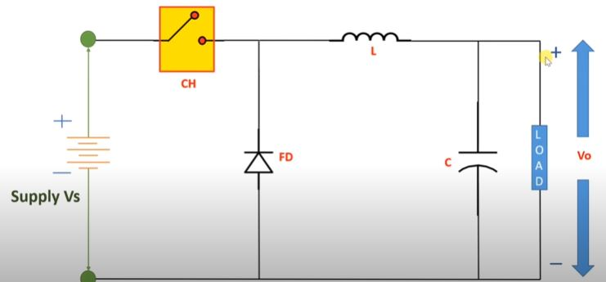

**Fig. 2(i) Circuit Diagram of Buck Converter**

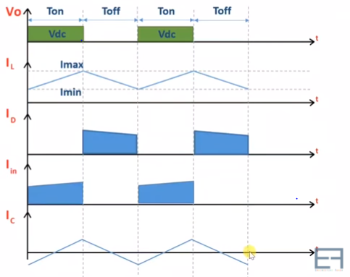

**Fig. 2(ii) Waveforms of Buck Converter**

**8**

**When CH is ON- Volt-sec Balance-**

Vl(ON) = Vs – Vo Vl(ON) * T(ON) + Vl(OFF) * T(OFF) = 0

Ic(ON) = Il – Io (Vs – Vo) * DT + (- Vo) * (1 – D)T = 0

Vo = D Vs (0 < D < 1)

**When CH is OFF- Ampere-sec Balance**

Vl(OFF) + Vo = 0 Ic(ON) * T(ON) + Ic(OFF) * T(OFF) = 0

Vl(OFF) = - Vo (Il – Io) * DT + (Il – Io) * (1 – D)T = 0

Ic(OFF) = Il – Io Il = Io

**High speed Opto-coupler**

An optocoupler or opto-isolator, is an electronic component that combination of optical transmitter and receiver in a single package. It is used to electrically isolate two circuits while allowing them to communicate optically. The optocoupler provides a way to transfer signals or electrical information between two isolated circuits without a direct electrical connection.

The basic structure of an optocoupler consists of an LED (light-emitting diode) on one side and a photodetector, usually a phototransistor or a photoresistor, on the other side. These components are housed in a single package with an opaque barrier between them to prevent direct electrical contact.

A simplified explanation of how an optocoupler works:

1. When a voltage is applied to the LED side of the optocoupler, the LED emits light.

2. The emitted light passes through the opaque barrier and reaches the photodetector on the other side.

3. The photodetector converts the received light into an electrical signal.

4. The electrical signal from the photodetector can then be used to control or drive the circuit on the receiving side of the optocoupler.

**9**

The optocoupler essentially acts as a signal transmitter and receiver, allowing electrical signals to be transmitted in the form of light and then converted back into electrical signals. This optical isolation provides protection against voltage spikes, noise, and potential ground loops between the two circuits.

Optocouplers are commonly used in various applications, including:

1. Isolation between high-voltage and low-voltage circuits in power supplies and motor control systems.

2. Communication between digital circuits in noisy environments.

3. Feedback control systems to monitor and regulate signals.

4. Protection against voltage surges and isolation in industrial control systems.

The specific type and configuration of an optocoupler can vary, such as with different types of photodetectors or additional features like built-in amplifiers or logic gates.

6N136 is a high speed optocoupler with transistor output. It can switch at a speed of 1M bit/sec

with bandwidth of 2MHz. It is TTL compatible with Open collector output commonly used in power supply circuits like inverter or in data transfer circuit as logic isolator.

Optocoupler isolation: This isolation provides several benefits, including:

Electrical isolation: The input and output sides of the optocoupler are physically separated, protecting one circuit from electrical disturbances, voltage spikes, and potential ground loops originating from the other circuit.

Signal transmission: The optocoupler uses light to transmit the electrical signal. When the input current flows through the LED, it emits light that is detected by the photodiode or phototransistor on the output side, converting the light back into an electrical signal.

Level shifting and noise reduction: Optocouplers can convert voltage levels and eliminate noise in signal transmission, making them useful for interfacing circuits with different voltage levels or in noisy environments.

**10**

Protection and safety: Optocouplers provide galvanic isolation, reducing the risk of electrical

shock and protecting sensitive components or circuits from high voltages or transients.

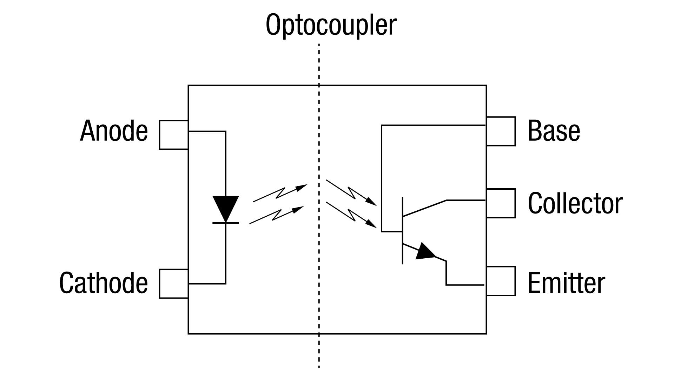

**Fig. 3(i) Internal Diagram of optocoupler**

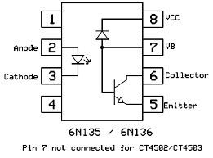

**Fig. 3(ii) Integrated Circuit of optocoupler**

**11**

**Liquid crystal display (LCD)**

The LCD 16*2, also known as a 16x2 character LCD, is a widely used display module that consists of 16 columns and 2 rows of characters. It is commonly used in various electronic devices and projects for displaying alphanumeric characters, symbols, and simple graphics.

The LCD 16*2 utilizes a liquid crystal display (LCD) technology to provide a clear and easy-to-read visual output. It is typically controlled by an external microcontroller or other control circuits through parallel or serial communication interfaces.

Each character position on the LCD 16*2 can display a single character, which is usually a standard ASCII character or a custom-defined character. The module supports a range of character sets and can display various languages and symbols.

The LCD 16*2 module requires a power supply to operate, usually in the form of a 5V DC voltage. It also requires a contrast adjustment, which is achieved by varying the voltage difference between the display's front and back electrodes.

The LCD 16*2 is commonly used in a wide range of applications, including consumer electronics, industrial control systems, measurement instruments, robotics, and DIY projects. Its compact size, simplicity of interfacing, and low power consumption make it a popular choice for displaying information in many electronic devices.

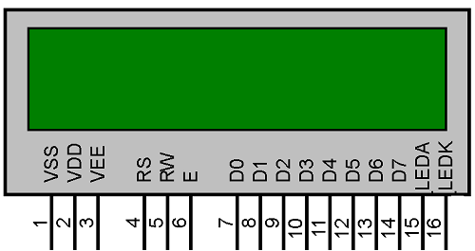

**Fig. 4 LCD Display**

**12**

**Relay**

A relay is an electrical device used in electronic circuits to control the flow of current or switching on or off the electronic circuit. It is an electromechanical switch that uses an electromagnet to mechanically open or close electrical contacts.

The basic construction of a relay includes the following components:

1. Coil: The coil is an insulated wire wound around a core. When current flows through the coil, it generates a magnetic field.

2. Contacts: Relays have one or more sets of contacts, which are switch-like terminals. These contacts can be normally open, normally closed, or both (changeover or SPDT). The contacts are electrically isolated from the coil and can be used to control the flow of current in other parts of the circuit.

3. Armature: The armature is a movable part that is attracted or released by the magnetic field generated by the coil. It is connected to the contacts and moves when the coil is energized or de-energized.

The operation of a relay involves the following steps:

1. When a current is applied to the coil, it creates a magnetic field, which attracts the armature and moves it toward the contacts.

2. As the armature moves, the contacts change position. In a normally open (NO) relay, the

normally open contacts close, allowing current to flow through them. In a normally closed (NC) relay, the normally closed contacts open, interrupting the current flow.

3. When the current to the coil is removed, the magnetic field collapses, and the spring-loaded armature returns to its original position, reversing the state of the contacts.

Relays are commonly used in various applications, including:

- Switching high-power circuits with low-power control signals, allowing the control of devices that require higher current or voltage levels.

- Providing electrical isolation between control circuits and power circuits, protecting control

**13**

circuitry from high voltages or currents.

- Signal amplification or isolation, where a weak signal is used to control a larger current or voltage.

- Timing circuits, where relays can be used to introduce time delays in a circuit.

- Automation and control systems, where relays are used for logic operations and interlocking.

Relays are versatile components that are widely used in many industries and applications, providing reliable switching and control capabilities for electronic circuits.

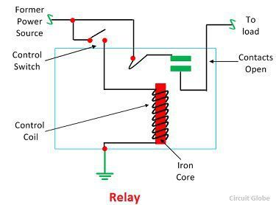

**Fig. 5(i) Internal Diagram of relay**

**14**

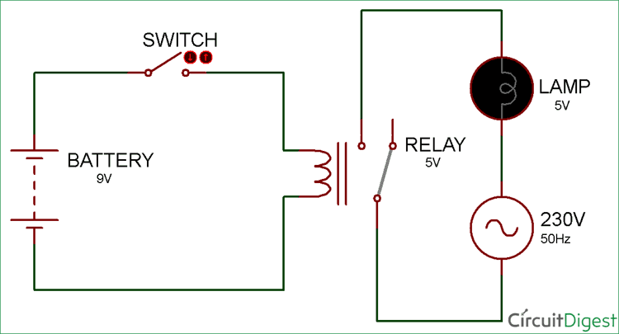

**Fig. 5(ii) Circuit Diagram of relay**

**LDR Sensor**

An LDR (Light Dependent Resistor), also known as a photoresistor or photocell, is a passive electronic component that changes its resistance in response to changes in light intensity. It is a type of sensor that detects and measures light levels in its surroundings.

The LDR sensor operates based on the principle of the photoconductivity of certain semiconductor materials. When light falls on the surface of the LDR, the energy from the light photons causes the conductivity of the material to change, resulting in a corresponding change in its resistance.

The use of LDR sensors is widespread across various applications, including:

1. Light sensing and control: LDR sensors are commonly used to automatically control lighting systems. They can be employed in streetlights, outdoor lighting, indoor lighting,

**15**

and automatic brightness adjustment of displays. When the ambient light level falls below a certain threshold, the resistance of the LDR increases, triggering the circuit to activate the lights.

2. Security systems: LDR sensors can be used in security systems to detect changes in ambient

light levels. For instance, in a burglar alarm, a sudden increase in light intensity (e.g., due to a flashlight) can trigger an alarm if the LDR detects the change.

3. Photography and camera exposure control: LDR sensors are used in cameras to measure the amount of light available and help adjust the camera's exposure settings accordingly.

4. Energy-saving systems: LDR sensors can be integrated into energy-saving devices to control the operation of electrical appliances or switch off lights when sufficient ambient light is available.

Overall, LDR sensors provide a cost-effective and simple solution for detecting and responding to changes in light levels. They find applications in a wide range of fields where light monitoring, control, or detection is required.

Photoresistor sensitivity is defined as change in resistance with respect to change in irradiance. The unit of photoresistor sensitivity is Ohm/W*m-2.

Photoresistor sensitivity formula:

S =

**16**

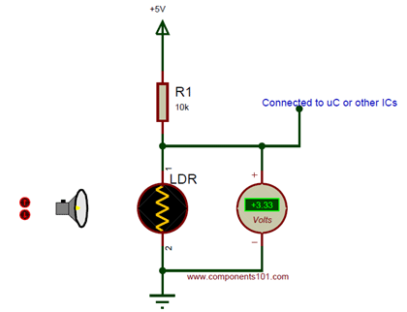

**Fig. 6(i) Circuit Diagram of LDR Sensor**

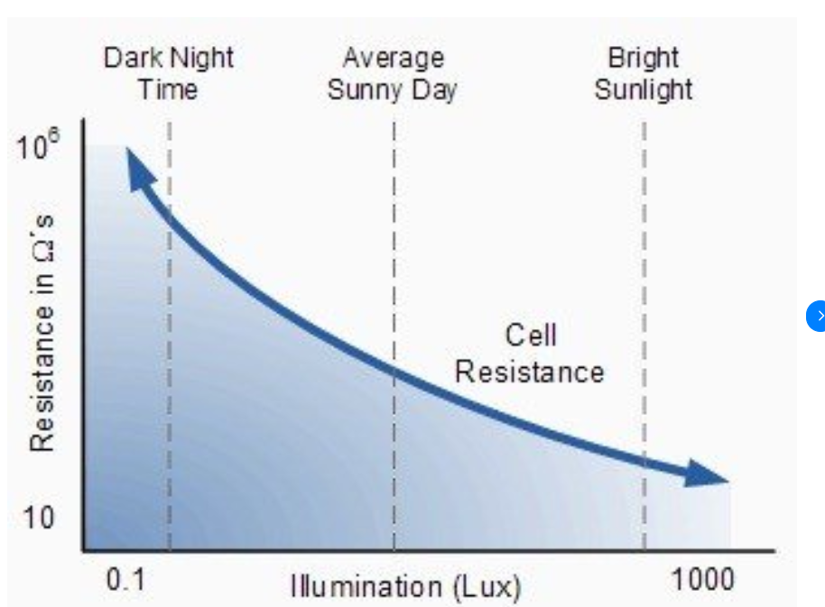

**Fig. 6(ii) Graph between Resistance versus Illumination (Lux)**

**17**

**CHAPTER -4**



**Calculations and Observations**

Calculating the electric vehicle (EV) charging capacity using photovoltaic (PV) systems involves several factors, including the power output of the PV system, the charging efficiency, the EV's battery capacity, and the charging time required. Here's a general outline of the calculation process:

1. Determine PV system capacity: Calculate the power output of your PV system by considering the total installed capacity of the solar panels. For example, if you have a PV system with a total capacity of 5 kW, the maximum power it can generate is 5 kW.

2. Consider PV system efficiency: Take into account the efficiency of the PV system, which represents the percentage of sunlight it can convert into electrical energy. Typical PV system efficiencies range from 15% to 20%. Multiply the PV system capacity by the efficiency factor to determine the effective power output available for charging the EV.

**Effective power output = PV system capacity x PV system efficiency**

3. Determine charging efficiency: Consider the charging efficiency, which represents the efficiency of converting electrical energy from the PV system into the EV's battery capacity. Charging efficiencies can vary, but a typical value is around 90%. Multiply the effective power output by the charging efficiency to calculate the power available for charging the EV.

**Charging power = Effective power output x Charging efficiency**

4. Determine charging time: Determine the desired or required charging time for the EV. This can vary depending on factors such as the battery capacity, desired charge level, and available sunlight hours.

**18**

1. Calculate energy required: Determine the energy required to charge the EV by multiplying

the charging power by the charging time.

**Energy required = Charging power x Charging time**

6. Assess battery capacity: Consider the battery capacity of the EV, which is typically measured in kilowatt-hours (kWh). Ensure that the calculated energy required does not exceed the EV's battery capacity.

It is important to note that the actual charging capacity may vary due to factors like weather conditions, system losses, and fluctuations in solar irradiance. Additionally, factors such as EV efficiency, battery condition, and driving habits may affect the actual energy consumption.

These calculations provide a general framework for estimating the charging capacity of an EV using a PV system. However, for more accurate and specific calculations, it is recommended to consult detailed technical specifications of the PV system, EV, and charging equipment or consult with a solar energy professional.

Pwlin generator is used in place of solar panel to generate the variable voltage with respect to time, as sun rays generate different voltage according to its intensity and time period throughout the day time.

According to schematic diagram, there are two terminals which are connected to the solar panel this two terminal further connected with buck converter each terminal generate variable voltage

with respect to time as shown in figures.

**19**

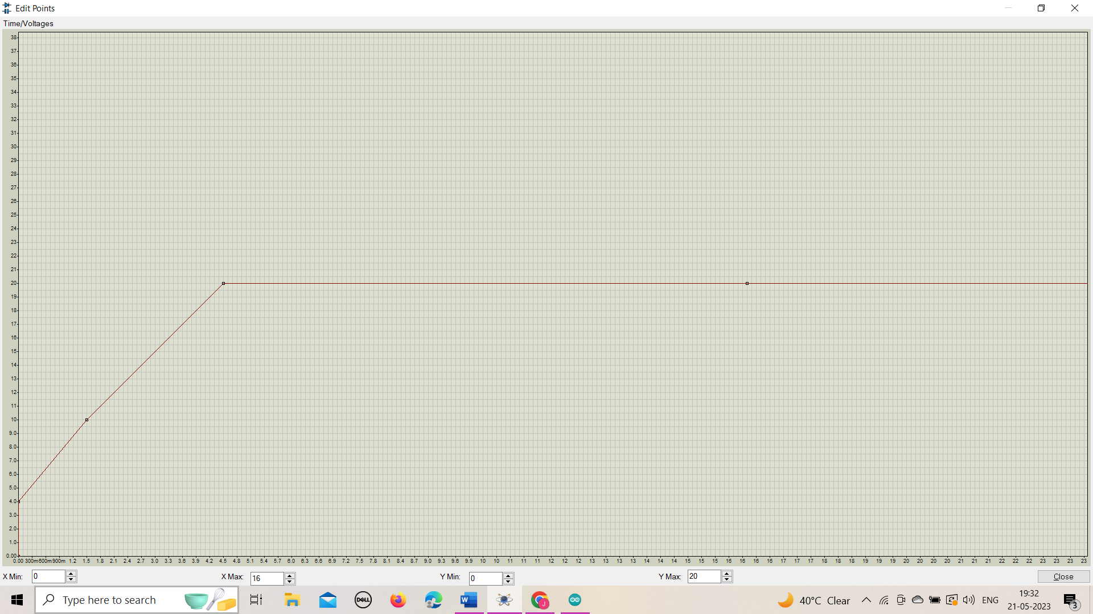

**Fig.7(i) Waveform of pwlin input of solar panel-1**

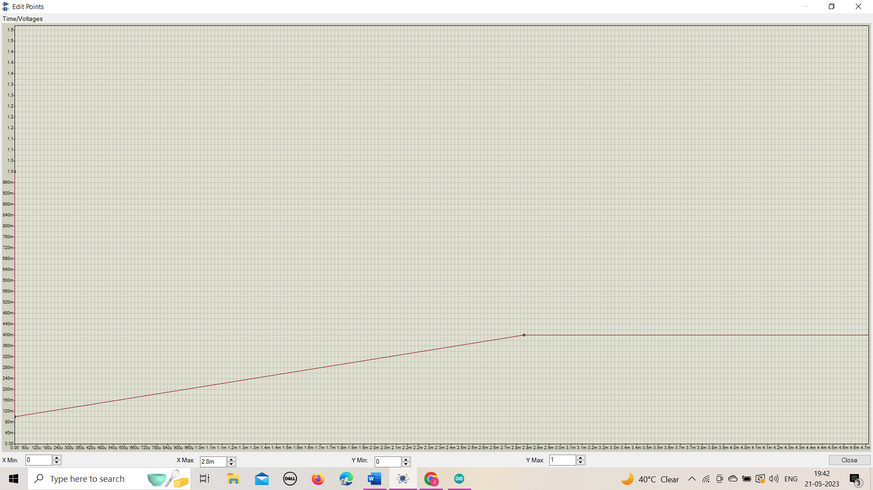

**Fig.7(ii) Waveform of pwlin input of solar panel-2**

**20**

The variable voltages values are high let say 20 volts but to design the solar charger of volt 10 volts then this high voltage need to step down in low voltage or required voltage for that Buck convertor is used.

According to the diagram, it is connected with capacitor of value 100uF, capacitor helps to reduces the fluctuations, then there is IRF740 transistor which is used for switching frequency and its is also used to increase or decrease the power transmission. There is a variable resistor which is connected to the transistor to change the switching frequency value, duty cycle value and it cause changes in output.

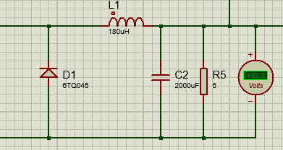

**Fig.8 Buck converter schematic diagram**

In the Buck converter, during first cycle inductor charged and then in second cycle inductor get discharge and capacitor charge due to load resistor and then cycle completed through diode, then output voltage observed int the voltmeter.

Sometimes buck converter is not required like when we need to design solar charger of 12 volts and we get the voltage of 12 to 14 volts from the solar panel then in this condition we do not need to step down the voltage.

Here, optocoupler is used for saturation between high voltage and low voltage as there is no physical connection, Infrared light falls on photodiode and current will flow from collector to emitter.

**21**

From Arduino, there is PWM pin from pin no 9 connected to the Anode of the optocoupler and cathode is connected with the ground. Here, Duty cycle set and transfer through pin no 9. Through this output pin from Arduino, frequency varies and transfer to the optocoupler, then infrared light falls on photodiode according to the changes in frequencies. These frequencies are calculated in Arduino, here the photodiode transistor in the optocoupler, Base is connected with one terminal of the solar panel and collector is connected with IRF740 transistor as a switching frequencies.

Base current and collector current will frow to the emitter, it is connected to the voltage divider, output of buck converter and output of optocoupler are connected with voltage divider, this voltage divider scale the voltage in range of maximum 5 volts as Arduino work in this range.

This output voltage transfer to the Arduino through the analog pin Ao.

Further, this voltage calculated and set in the feasible value and transfer to the LCD from where results will be observed.

Solar panel are useful in day time so for the night time DC supply are used for charging purpose,

For this LDR sensor is used. LDR sensor is directly connected with the analog pin A2 of the Arduino.

Suppose at day time, Light intensity is high (>400 LUX) from average sunny day to bright sunlight which is the actual value according to the survey. According to the relation, output pin 8 gives indication to yellow light and through output pin 2 relay is connected which is switching device, in this condition relay switch the charging point to the solar panel charging voltage. And in the night time, Light intensity is low (<400 LUX) dark night time and output pin 10 gives indication to blue light and in this condition relay switch the charging point to the DC power supply to charge the electric vehicle.

**22**

**CHAPTER -5**

**Schematic Diagram**

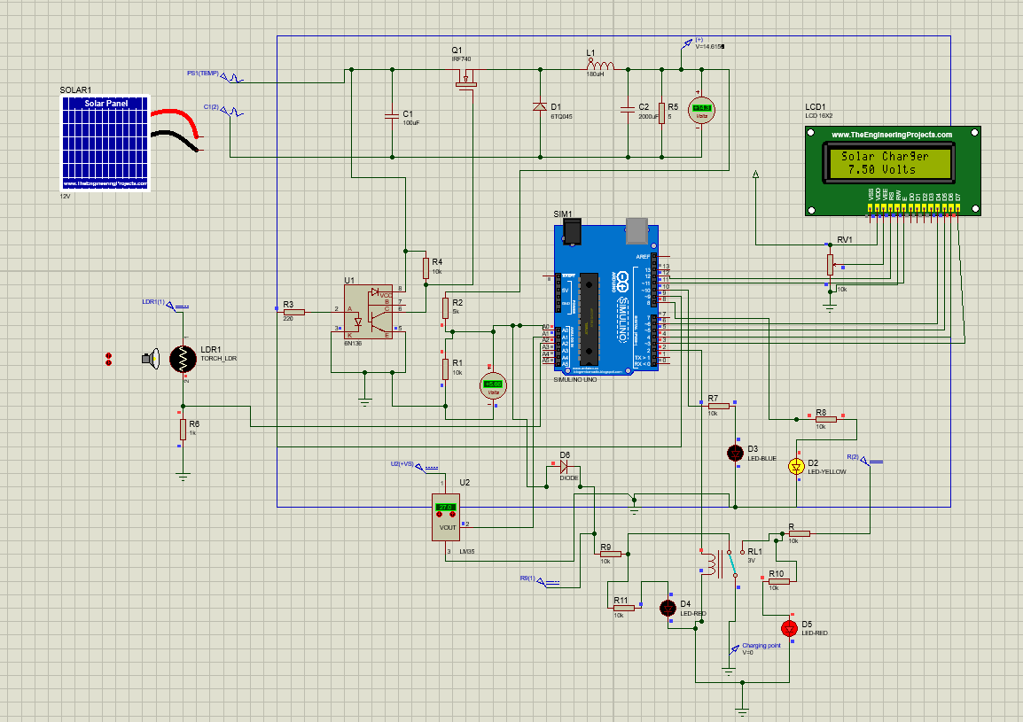

**Fig. 9 Schematic Representation of Charging using Photovoltaic System**

**23**

**CHAPTER-6**

**Conclusion and Future scope**

By integrating photovoltaic systems with electric vehicle charging infrastructure, we can pave the way for a sustainable and cleaner future. This project report aims to provide a comprehensive analysis of the feasibility, benefits, and challenges associated with this integration. The findings will contribute to the growing body of knowledge on PV-based EV charging systems and serve as a valuable resource for policymakers, researchers, and industry professionals seeking to drive the transition towards sustainable transportation.

The future scope for charging electric vehicles (EVs) using photovoltaic (PV) systems is quite promising. Advancements in solar technology, such as more efficient and affordable PV panels, will make PV-based EV charging more accessible. Integrating PV systems with smart grid technologies will optimize charging and grid stability. Energy storage solutions will enhance reliability, and scaling up deployment of PV-based charging infrastructure will be important. Collaboration among stakeholders and supportive policies will drive the adoption of PV-based EV charging. The future holds a cleaner and more sustainable transportation system powered by solar energy.

**24**

**References**

* Y.-M. Wi. J.-U. Lee, and S.-K. Joo, “Smart electric vehicle charging for smart home/building with a photovoltaic system,” Int. Conf. Consumer Electron. 2018, May 2018
* Z. Liu, F. Wen, and G. Ledwich, “Optimal planning of electric-vehicle charging stations in distribution systems,” IEEE Trans. Power Del., vol. 28, no. 1, pp. 102–110, Jan. 2021.
* <https://electronicscoach.com/buck-converter.html>
* <https://www.elprocus.com/ldr-light-dependent-resistor-circuit-and-working/>
* <https://www.electronics-tutorials.ws/blog/optocoupler.html>
* <https://in.mathworks.com/discovery/arduino-programming-matlab-simulink.html>

**25**

**Appendix**

**Code**

#include<LiquidCrystal.h>

LiquidCrystal lcd(12,11,6,5,4,3);

int abc=0;

float vol=0.0;

double freq=70000.0;

double duty=50.0;

float sensorvalue=0;

void setup() {

// put your setup code here, to run once:

pinMode(9,OUTPUT);

pinMode(2,OUTPUT);

pinMode(8,OUTPUT);

pinMode(10,OUTPUT);

lcd.begin(16,2);

Serial.begin(9400);

lcd.setCursor(1,0);

lcd.print("Solar Charger");

TCCR1A=_BV(COM1A1);

**26**

TCCR1B=_BV(WGM13) | _BV(CS10);

}

void loop(){

sensorvalue=analogRead(A2);

if(sensorvalue>400){

digitalWrite(2,HIGH);

digitalWrite(10,LOW);

digitalWrite(8,HIGH);

}

else

{

digitalWrite(8,LOW);

digitalWrite(2,LOW);

digitalWrite(10,HIGH);

}

// put your main code here, to run repeatedly:

volt=5.0*(analogRead(A0)/1023.0)*(7.5/5);

delay(200);

/*

sensorvalue=analogRead(A2);

if(sensorvalue>3){

digitalWrite(2,LOW);

digitalWrite(8,HIGH);

}

else

{

digitalWrite(8,LOW);

digitalWrite(2,HIGH);

**27**

}

//delay(5000);

*/

// FWM(freq, duty);

lcd.setCursor(2,1);

lcd.print(volt);

lcd.setCursor(7,1);

lcd.print("Volts");

/*

if(volt<4.5){

duty=duty+1.0;

}

if(volt>5.2){

duty=duty-1.0;

}

*/

}

void FWM(float freq, float duty){

ICR1=16000000.0/(2.0*freq);

OCR1A=ICR1*(duty/100.0);

}

**Above code is converted into hex file then it will upload to the Arduino in proteus tool.**

**28**